**Peace in our lives**

**Reading: Mark 4:35-41**

When evening came, Jesus said to his disciples, “Let’s go over to the other side of the lake.” They left the crowd behind. And they took him along in a boat, just as he was. There were also other boats with him. A wild storm came up. Waves crashed over the boat. It was about to sink. Jesus was in the back, sleeping on a cushion. The disciples woke him up. They said, “Teacher! Don’t you care if we drown?”

He got up and ordered the wind to stop. He said to the waves. “Quiet! Be still!” Then the wind died down. And it was completely calm.

He said to his disciples, “Why are you so afraid? Don’t you have any faith at all yet?”

They were terrified. They asked each other, “Who is this? Even the wind and the waves obey him!”

**Thought about the reading**

Jesus promised that he would give his peace to his followers. But what is peace?

How does it feel when you don’t have peace? It is when you feel worried, upset, frightened.

When you feel peaceful, you feel quiet, happy and safe.

In the story today, Jesus and his friends went in a boat over the lake. His friends were very frightened because a big storm came, and they thought they were going to die. They did not feel peaceful! They were very frightened and worried.

Jesus listened to them when they asked him for help. He told the wind and waves to be still. He helped them through the storm.

Sometimes we can feel frightened by what is happening to us. If we ask Jesus, he will listen to us and help us. He will keep us safe when there is trouble. He will give us his peace.

**Prayer**

Dear Jesus, thank you for your promise to give us your peace. Please help me to tell you when I am frightened or worried.

Please help me when things are frightening.

Please give me your peace.

Amen

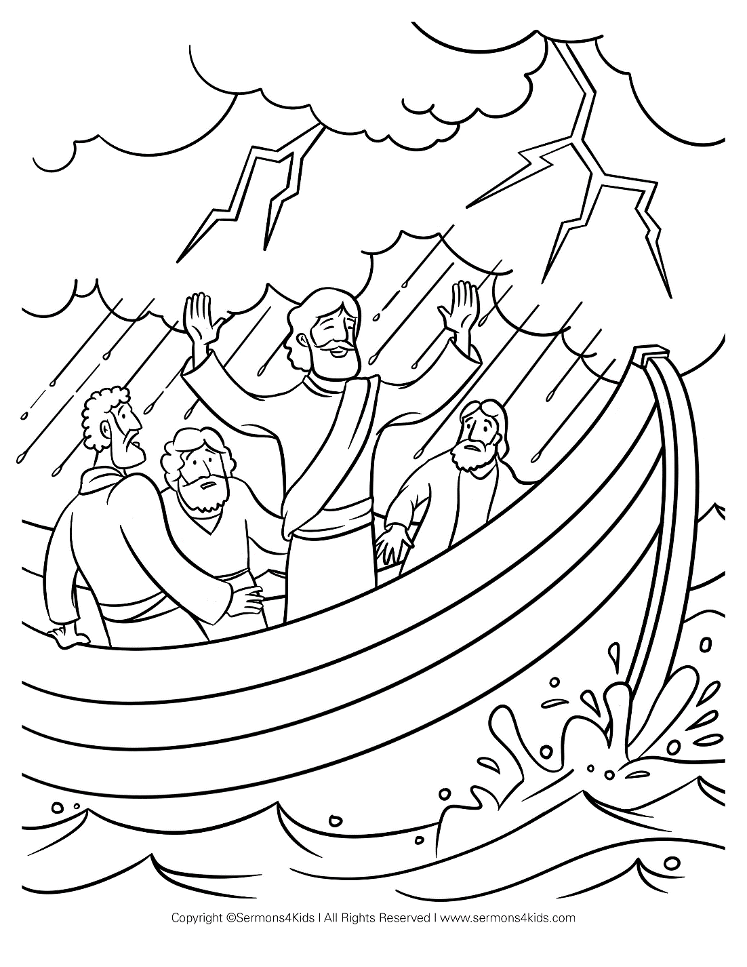

**Cambridge Causeway**

Autumn 2024

Bible Study notes

**What Jesus has done for me**

**3. Peace in our lives**

By Chrissy Cole